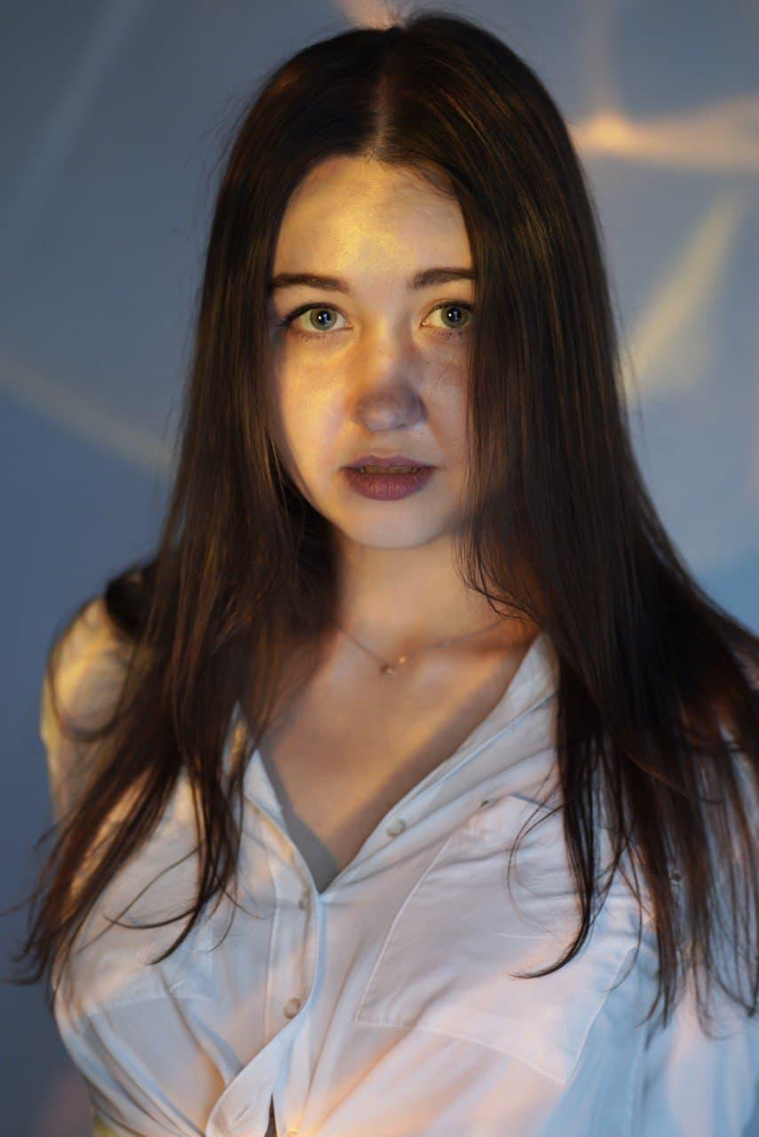

| Grushka Daria  Highly driven front-end specialist with integration skills and strong academic background in computer science. Driven by the eagerness to learn, I have been working as a full-time front-end developer for the past 3 years alongside managing intense bachelor's and master's degrees. |  |
| --- | --- |
| WORKING EXPERIENCEFIDESINT. Integration consultancy – in*tegration developer* Kyiv, Ukraine SEPTEMBER 2020 – NOWADAYSDesigned and developed a [website](https://fidesint.com/) for a company, also implemented a SEO optimization and activity tracking tools to it. Throughout my experience with this company, all communication within was in English. Therefore, I speak it very fluently and communicate freely on technical topics. I’m working as an integration technical specialist, configure message broker flows using IBM MQ (IBM WebSphere MQ) and develop applications using App Connect Enterprise (IBM Integration Bus) solutions. Integration skills listed in a separate section below, they are reflect my daily tasks.AD VISER. Financial company – *team lead* Kyiv, Ukraine SEPTEMBER 2020 – OCTOBER 2021 First half of a year I was the only front-end developer, so I did all the functions related to the front-end part for the company's applications. Then became a team lead for a small development team, including front-end, back-end, and design developers.  - Was responsible for the entire development process, formed and delegated tasks to the rest of the project developers, worked on 7 projects at the same time.  - Developed a framework for building companies' projects and documented it.  - Improved site pages performance and accessibility metrics by %15-%10 relied on Lighthouse metrics (the sites had a monthly turnover of about 100k users).  - Developed and scaled 4 existing and 3 new company’s projects.  - Interview engineers and onboard new team members.  - Created and optimized solutions across multiple devices and screens, including desktops, tablets, and smartphones for the company’s projects.  - Built, tested, and deployed pages for the company’s websites (HTML, SCSS, JavaScript, JQuery, Twig PHP Template, Unify toolkit and Gulp) Aweb Systems. Marketing company – *front-end developer* Kyiv, UkraineJULY 2019 – FEBRUARY 2020 Had worked as a Front-End developer in WEB-Studio. Was a part of a small team on a variety of development projects and delivered solutions to meet and exceed clients’ briefs. Developed a lot of adaptive websites using all skills mentioned in the relevant section, also implemented SEO solutions in each of these projects. The skills were chosen according to the customer's requirements. EDUCATION[National University of 'Kyiv Mohyla Academy'](https://www.ukma.edu.ua/eng/),  Kyiv– *bachelor*SEPTEMBER 2015 – JULY 2019 Received a bachelor’s degree in Computer Science. Grade: 85/100. Was a front-end developer of 5 group projects (each project was rated 91+ out of 100). My thesis was about the construction of cospectral graphs with respect to the generalized adjacency matrix. Spectral graph theory uses the eigenvalues of matrices associated with a graph to determine the structural properties of the graph. I designed a tool that allows classifying graphs based on their cospectrality. [Mykhailo Ostrohradskyi National University](http://www.kdu.edu.ua/en/main.php),  Kremenchuk – *master*SEPTEMBER 2015 – JANUARY 2021 Received a master's degree in Computer Science. Grade: 86/100. The thesis was about using scale-invariant feature transform descriptors to map a template and an image, improved algorithm for matching pattern and image, by calculations using DoG (difference of Gaussians) detectors, directional gradients of key points, and their scale-independent transformation (descriptors), which allows flexible comparison of pattern and image under different conditions, including lighting, affine transformations, complex scenes, etc.  **INTEGRATION SKILLS**  **Expertise in IBM ACE/IIB (distr.)**  - Analyse, design, and implement enterprise integration solutions.  - Expertise in ACE and IIB development.  - Experience in message flow development.  - Data transformation using ESQL, compute and Java compute nodes.  - Experience in message models CSV, DFDL, XML.  - Processing HTTP and WEB service messages.  - Installation and deployment. Expertise in IBM MQ (distr.) - Analyse, design, and implement enterprise messaging solutions using IBM MQ.  - Expert in MQ Administration.  - Automation using MQSC, Shell and Expect scripts.  - Strong expertise in High Availability solutions (RDQM, multi-instance queue managers).  - Plan and implement an appropriate backup strategy.  - Expertise in MQ Clustering.  - Deep expertise in MQ security (TLS, AMS, CONNAUTH, CHLAUTH).  - MQ best practices. | Kyiv, Ukraine Currently live in **Izmir, Turkey**  **+38 (068) 066-87-80** [dasha.g1917@gmail.com](mailto:dasha.g1917@gmail.com)  telegram: **@kldasha**  website: [portfolio](https://dashagr.github.io/portfolio/) DEV SKILLS *HTML, CSS, SASS (SCSS), Unify, Bootstrap, JavaScript, JQuery, XML, XSD, Lighthouse, MySQL, NoSql, Mongodb, JSON, basic PHP, Twig, Git, Gulp, WordPress, Joomla, ModX, October, MegaGroup, Bitrix, OpenCart, Tilda, Figma, Avocode, Photoshop, Windows, Linux, IBM MQ, IBM ACE (IIB), IBM MQ Appliance, Shell, Bash, MQSC, Expect scripting, DFDL.* LANGUAGES  English - B2, free speaking  Russian - native speaker   Ukrainian - native speaker  ARTICLES [The construction of cospectral graphs with respect to the generalized adjacency matrix](https://vixra.org/pdf/1906.0502v1.pdf);  "Cospectral graphs and the generalized adjacency matrix" for the [KPI scientific conference](https://fmf.npu.edu.ua/se/konf/984-vii-vseukrayinska-konferentsiya-studentiv-aspirantiv-ta-molodykh-vchenykh-z-matematyky);  "Keypoint SIFT descriptors" for the international scientific conference ["Semiconductor materials, IT and photovoltaics"](http://nmitf.kdu.edu.ua/index.php/ua/);  "Using SIFT (Scale Invariant Feature Transform) descriptors for mapping template and image" for the "IT perspective" magazine. |